**VISVESVARAYA TECHNOLOGICAL UNIVERSITY**

**“Jnana Sangama”, Belagavi-590018.**

**

**“Movie Recommender System”**

**INTRODUCTION TO PYTHON PROGRAMMING**

**PROJECT REPORT**

**Submitted by**

**Shashank Ravindra 1RF23CS152**

**Ananya Raghuveer 1RF23CS021**

**Srushti Sunil V 1RF23CS168**

**Under the Guidance of**

**Dr. Mallanagouda Patil,**

**Associate Professor,**

**Department of CSE**

**RV INSTITUTE OF TECHNOLOGY AND MANAGEMENT, BANGALORE-560076**

**2023-24**

**RV INSTITUTE OF TECHNOLOGY AND MANAGEMENT, BANGALORE - 560076**

**DEPARTMENT OF COMPUTER SCIENCE AND ENGINEERING**

**CERTIFICATE**

Certified that the project work titled **“Movie Recommender System”** is carried out by**Shashank Ravindra (1RF23CS152), Ananya Raghuveer (1RF23CS021), Srushti Sunil V (1RF23CS168)** who are bonafide students of RV Institute of Technology and Management, Bangalore**.**

|  |  |  |
| --- | --- | --- |
| **Dr.** **Mallanagouda Patil** | **Dr. Malini M Patil** | **Dr. Jayapal R** |
| Associate Professor, | Professor & Head, | Principal, |
| Department of CSE, | Department of CSE, | RVITM, Bengaluru-76 |
| RVITM, Bengaluru-76 | RVITM, Bengaluru-76 |  |

**Signature of Guide: Signature of Head of the Department: Signature of Principal:**

**DECLARATION**

We, Shashank Ravindra (1RF23CS152), Ananya Raghuveer (1RF23CS021) and Srushti Sunil V (1RF23CS168), students of second semester B.E., hereby declare that the project titled “Movie Recommender System” has been carried out by us and submitted in fulfilment of the Python Mini Project. We further declare that this work has not been carried out by any other students for the fulfilment of any other project.

**Place : Bangalore Signature**

**Date : June 2024 1. Shashank Ravindra (1RF23CS152)**

**2. Ananya Raghuveer (1RF23CS021)**

**3. Srushti Sunil V (1RF23CS168)**

**ABSTRACT**

This Python-based movie recommender system prioritizes user engagement and simplicity, employing a structured data repository to store movie details, including titles, genres, and user ratings on a scale from 1 to 5. Users contribute ratings to build a dynamic recommendation engine via a straightforward interface, facilitating personalized movie suggestions without complex user profiles. Participation involves submitting new movies and ratings, enriching the system's database for more tailored recommendations. Users can select genres and set minimum rating thresholds to receive curated lists of recommended movies, leveraging both genre preferences and user-defined criteria. This project serves as a foundation for exploring advanced recommendation algorithms like collaborative and content-based filtering, fostering a continuously evolving and sophisticated recommendation system.

**INTRODUCTION**

This mini project delves into the realm of movie recommendations, offering a user-centric system built with Python. It aims to create a collaborative environment where users can contribute their movie preferences and discover new movies based on shared tastes.

**Key Features:**

* **User-Driven Movie Database:** The system empowers users to enrich its knowledge base by adding new movies. Users can specify the title, genre, and their personal rating for each movie, fostering a dynamic and ever-evolving collection.
* **Personalized Recommendations:** Tailored movie suggestions are the heart of the system. Users can select a desired genre and set a minimum rating threshold. The system then analyses user-generated ratings and recommends movies that align with the chosen genre and meet or exceed the specified rating criteria.
* **Collaborative Filtering Potential:** This foundational system lays the groundwork for incorporating more sophisticated recommendation algorithms in the future. Techniques like collaborative filtering, which analyses the ratings of similar users, can be integrated to provide even more personalized suggestions.

**Objectives:**

* **Build a User-Friendly Platform:** The project strives to create an intuitive and user-friendly interface that allows users to seamlessly interact with the system.
* **Encourage Collaborative Exploration:** The core objective is to foster a collaborative environment where users contribute their movie preferences, enriching the database and benefiting from the collective knowledge base.
* **Provide Personalized Recommendations:** The system aims to leverage user-generated data to deliver personalized movie suggestions that cater to individual tastes and preferences.
* **Serve as a Stepping Stone:** This mini project serves as a springboard for further exploration of recommendation algorithms. By providing a foundational framework, it paves the way for incorporating more advanced techniques to create an even more robust and intelligent recommendation system.

Overall, this project offers a practical introduction to the world of movie recommendations. It highlights the power of user-driven data and lays the groundwork for exploring more intricate algorithms that can deliver increasingly personalized movie suggestions for users.

This user-friendly movie recommender system empowers you to explore the world of cinema with ease. With just a few numbers as input, you can unlock a treasure trove of personalized movie recommendations, fostering a collaborative movie discovery experience.

**CODE**

import sys  
  
  
class MovieRecommender:  
 def __init__(self):  
 self.movies = {} *# Dictionary to store movie information* self.genres = {1: "Action", 2: "Comedy", 3: "Documentary", 4: "Drama", 5: "Family", 6: "Fantasy", 7: "Horror",  
 8: "Sci-Fi", 9: "Romance", 10: "Thriller"} *# Genre mapping* self.populate_movies() *# Initialize the movies dictionary with some predefined movies* def add_movie(self, title, genre, initial_rating):  
 *# Add a new movie with its initial rating to the movies dictionary* if title not in self.movies:  
 self.movies[title] = {'genre': genre, 'ratings': [initial_rating]}  
 else:  
 self.movies[title]['ratings'].append(initial_rating)  
  
 def rate_movie(self, title, genre, rating):  
 *# Rate an existing movie or add it to the database if it doesn't exist* if title in self.movies:  
 self.movies[title]['ratings'].append(rating)  
 print(f"Rating '{rating}' added for movie '{title}'.")  
 else:  
 self.add_movie(title, genre, rating)  
 print(f"Movie '{title}' added to the database with rating '{rating}'.")  
  
 def get_average_rating(self, title):  
 *# Calculate and return the average rating for a given movie* if title in self.movies:  
 ratings = self.movies[title]['ratings']  
 return sum(ratings) / len(ratings)  
 return 0  
  
 def get_recommendations(self, genre, rating):  
 *# Recommend movies based on genre and a specific rating* recommended_movies = []  
 for title, info in self.movies.items():  
 if info['genre'].lower() == genre.lower() and self.get_average_rating(title) == rating:  
 recommended_movies.append(title)  
 return recommended_movies  
  
 def populate_movies(self):  
 movies = {  
 *# Action movies* "Mad Max: Fury Road (2015)": {"genre": "Action", "ratings": [5]},  
 "Lakshya (2004)": {"genre": "Action", "ratings": [5]},  
 "Uri: The Surgical Strike (2019)": {"genre": "Action", "ratings": [5]},  
 "The Terminator (1984)": {"genre": "Action", "ratings": [5]},  
 "Die Hard (1988)": {"genre": "Action", "ratings": [5]},  
 "Gladiator (2000)": {"genre": "Action", "ratings": [5]},  
 "Baahubali 2: The Conclusion (2017)": {"genre": "Action", "ratings": [5]},  
 "Dhoom 2 (2006)": {"genre": "Action", "ratings": [5]},  
 "War (2019)": {"genre": "Action", "ratings": [5]},  
 "KGF: Chapter 1 (2018)": {"genre": "Action", "ratings": [5]},  
 "Vishwaroopam (2013)": {"genre": "Action", "ratings": [5]},  
 "Léon: The Professional (1994)": {"genre": "Action", "ratings": [4]},  
 "John Wick (2014)": {"genre": "Action", "ratings": [4]},  
 "The Matrix (1999)": {"genre": "Action", "ratings": [4]},  
 "Mission: Impossible - Fallout (2018)": {"genre": "Action", "ratings": [4]},  
 "The Bourne Identity (2002)": {"genre": "Action", "ratings": [4]},  
 "Dhoom (2004)": {"genre": "Action", "ratings": [4]},  
 "Bang Bang! (2014)": {"genre": "Action", "ratings": [4]},  
 "Robot (2010)": {"genre": "Action", "ratings": [4]},  
 "Commando (2013)": {"genre": "Action", "ratings": [4]},  
 "War (2019)": {"genre": "Action", "ratings": [4]},  
 "The Expendables (2010)": {"genre": "Action", "ratings": [3]},  
 "Tomb Raider (2018)": {"genre": "Action", "ratings": [3]},  
 "Battleship (2012)": {"genre": "Action", "ratings": [3]},  
 "G.I. Joe: The Rise of Cobra (2009)": {"genre": "Action", "ratings": [3]},  
 "Brothers (2015)": {"genre": "Action", "ratings": [3]},  
 "Force (2011)": {"genre": "Action", "ratings": [3]},  
 "Tevar (2015)": {"genre": "Action", "ratings": [3]},  
 "Dishoom (2016)": {"genre": "Action", "ratings": [3]},  
 "Race 2 (2013)": {"genre": "Action", "ratings": [3]},  
 "Speed 2: Cruise Control (1997)": {"genre": "Action", "ratings": [2]},  
 "A Good Day to Die Hard (2013)": {"genre": "Action", "ratings": [2]},  
 "Battlefield Earth (2000)": {"genre": "Action", "ratings": [2]},  
 "Catwoman (2004)": {"genre": "Action", "ratings": [2]},  
 "The Last Airbender (2010)": {"genre": "Action", "ratings": [2]},  
 "Himmatwala (2013)": {"genre": "Action", "ratings": [2]},  
 "Joker (2012)": {"genre": "Action", "ratings": [2]},  
 "Kites (2010)": {"genre": "Action", "ratings": [2]},  
 "Himmat (1996)": {"genre": "Action", "ratings": [2]},  
 "Ballistic: Ecks vs. Sever (2002)": {"genre": "Action", "ratings": [1]},  
 "Alone in the Dark (2005)": {"genre": "Action", "ratings": [1]},  
 "Gigli (2003)": {"genre": "Action", "ratings": [1]},  
 "Superbabies: Baby Geniuses 2 (2004)": {"genre": "Action", "ratings": [1]},  
 "Catwoman (2004)": {"genre": "Action", "ratings": [1]},  
 "Himmatwala (2013)": {"genre": "Action", "ratings": [1]},  
 "Prince (2010)": {"genre": "Action", "ratings": [1]},  
 "Chandni Chowk to China (2009)": {"genre": "Action", "ratings": [1]},  
  
 *# Comedy movies* "Groundhog Day (1993)": {"genre": "Comedy", "ratings": [5]},  
 "The Grand Budapest Hotel (2014)": {"genre": "Comedy", "ratings": [5]},  
 "Monty Python and the Holy Grail (1975)": {"genre": "Comedy", "ratings": [5]},  
 "Superbad (2007)": {"genre": "Comedy", "ratings": [5]},  
 "Anchorman: The Legend of Ron Burgundy (2004)": {"genre": "Comedy", "ratings": [5]},  
 "Hera Pheri (2000)": {"genre": "Comedy", "ratings": [5]},  
 "Munna Bhai M.B.B.S. (2003)": {"genre": "Comedy", "ratings": [5]},  
 "Golmaal:Fun Unlimited (2006)": {"genre": "Comedy", "ratings": [5]},  
 "Chupke Chupke (1975)": {"genre": "Comedy", "ratings": [5]},  
 "Ferris Bueller's Day Off (1986)": {"genre": "Comedy", "ratings": [4]},  
 "The Hangover (2009)": {"genre": "Comedy", "ratings": [4]},  
 "Napoleon Dynamite (2004)": {"genre": "Comedy", "ratings": [4]},  
 "Mean Girls (2004)": {"genre": "Comedy", "ratings": [4]},  
 "Dumb and Dumber (1994)": {"genre": "Comedy", "ratings": [4]},  
 "Welcome (2007)": {"genre": "Comedy", "ratings": [4]},  
 "Lage Raho Munna Bhai (2006)": {"genre": "Comedy", "ratings": [4]},  
 "Entertainment (2014)": {"genre": "Comedy", "ratings": [4]},  
 "Queen (2013)": {"genre": "Comedy", "ratings": [4]},  
 "Vicky Donor (2012)": {"genre": "Comedy", "ratings": [4]},  
 "Step Brothers (2008)": {"genre": "Comedy", "ratings": [3]},  
 "Hot Tub Time Machine (2010)": {"genre": "Comedy", "ratings": [3]},  
 "Zoolander (2001)": {"genre": "Comedy", "ratings": [3]},  
 "Tropic Thunder (2008)": {"genre": "Comedy", "ratings": [3]},  
 "Get Him to the Greek (2010)": {"genre": "Comedy", "ratings": [3]},  
 "Housefull (2010)": {"genre": "Comedy", "ratings": [3]},  
 "Golmaal: Fun Unlimited (2006)": {"genre": "Comedy", "ratings": [3]},  
 "Dhamaal (2007)": {"genre": "Comedy", "ratings": [3]},  
 "Bol Bachchan (2012)": {"genre": "Comedy", "ratings": [3]},  
 "Total Dhamaal (2019)": {"genre": "Comedy", "ratings": [3]},  
 "Norbit (2007)": {"genre": "Comedy", "ratings": [2]},  
 "Jack and Jill (2011)": {"genre": "Comedy", "ratings": [2]},  
 "Movie 43 (2013)": {"genre": "Comedy", "ratings": [2]},  
 "Gigli (2003)": {"genre": "Comedy", "ratings": [2]},  
 "The Love Guru (2008)": {"genre": "Comedy", "ratings": [2]},  
 "Humshakals (2014)": {"genre": "Comedy", "ratings": [2]},  
 "Joker (2012)": {"genre": "Comedy", "ratings": [2]},  
 "Yamla Pagla Deewana 2 (2013)": {"genre": "Comedy", "ratings": [2]},  
 "Disaster Movie (2008)": {"genre": "Comedy", "ratings": [1]},  
 "Epic Movie (2007)": {"genre": "Comedy", "ratings": [1]},  
 "Meet the Spartans (2008)": {"genre": "Comedy", "ratings": [1]},  
 "Himmatwala (2013)": {"genre": "Comedy", "ratings": [1]},  
 "Joker (2012)": {"genre": "Comedy", "ratings": [1]},  
 "Kyaa Super Kool Hain Hum (2012)": {"genre": "Comedy", "ratings": [1]},  
 "Great Grand Masti (2016)": {"genre": "Comedy", "ratings": [1]},  
  
 *# Documentary movies* "13th (2016)": {"genre": "Documentary", "ratings": [5]},  
 "Free Solo (2018)": {"genre": "Documentary", "ratings": [5]},  
 "The Kashmir Files (2022)": {"genre": "Documentary", "ratings": [5]},  
 "The Vaccine War (2023)": {"genre": "Documentary", "ratings": [5]},  
 "Article 370 (2024)": {"genre": "Documentary", "ratings": [5]},  
 "Sachin: A Billion Dreams (2017)": {"genre": "Documentary", "ratings": [4]},  
 "Won't You Be My Neighbor? (2018)": {"genre": "Documentary", "ratings": [5]},  
 "Jiro Dreams of Sushi (2011)": {"genre": "Documentary", "ratings": [5]},  
 "Man on Wire (2008)": {"genre": "Documentary", "ratings": [5]},  
 "The Act of Killing (2012)": {"genre": "Documentary", "ratings": [5]},  
 "Amy (2015)": {"genre": "Documentary", "ratings": [5]},  
 "The Cove (2009)": {"genre": "Documentary", "ratings": [5]},  
 "Searching for Sugar Man (2012)": {"genre": "Documentary", "ratings": [5]},  
 "Blackfish (2013)": {"genre": "Documentary", "ratings": [5]},  
 "Grizzly Man (2005)": {"genre": "Documentary", "ratings": [4]},  
 "Oppenheimer (2023)": {"genre": "Documentary", "ratings": [4]},  
 "The Fog of War (2003)": {"genre": "Documentary", "ratings": [4]},  
 "Exit Through the Gift Shop (2010)": {"genre": "Documentary", "ratings": [4]},  
 "Life Itself (2014)": {"genre": "Documentary", "ratings": [4]},  
 "An Inconvenient Truth (2006)": {"genre": "Documentary", "ratings": [4]},  
 "March of the Penguins (2005)": {"genre": "Documentary", "ratings": [4]},  
 "Fahrenheit 9/11 (2004)": {"genre": "Documentary", "ratings": [4]},  
 "Citizenfour (2014)": {"genre": "Documentary", "ratings": [4]},  
 "The Social Dilemma (2020)": {"genre": "Documentary", "ratings": [4]},  
 "Bowling for Columbine (2002)": {"genre": "Documentary", "ratings": [4]},  
 "Supersize Me (2004)": {"genre": "Documentary", "ratings": [3]},  
 "Waiting for 'Superman' (2010)": {"genre": "Documentary", "ratings": [3]},  
 "Food, Inc. (2008)": {"genre": "Documentary", "ratings": [3]},  
 "Shabaash Mithu (2022)": {"genre": "Documentary", "ratings": [3]},  
 "The King of Kong: A Fistful of Quarters (2007)": {"genre": "Documentary", "ratings": [3]},  
 "This Is Spinal Tap (1984)": {"genre": "Documentary", "ratings": [3]},  
 "Icarus (2017)": {"genre": "Documentary", "ratings": [3]},  
 "Gasland (2010)": {"genre": "Documentary", "ratings": [3]},  
 "Enron: The Smartest Guys in the Room (2005)": {"genre": "Documentary", "ratings": [3]},  
 "Inside Job (2010)": {"genre": "Documentary", "ratings": [3]},  
 "13th (2016)": {"genre": "Documentary", "ratings": [3]},  
 "Expelled: No Intelligence Allowed (2008)": {"genre": "Documentary", "ratings": [2]},  
 "The Bridge (2006)": {"genre": "Documentary", "ratings": [2]},  
 "An Inconvenient Sequel: Truth to Power (2017)": {"genre": "Documentary", "ratings": [2]},  
 "The Wolfpack (2015)": {"genre": "Documentary", "ratings": [2]},  
 "Catfish (2010)": {"genre": "Documentary", "ratings": [2]},  
 "Jesus Camp (2006)": {"genre": "Documentary", "ratings": [2]},  
 "Sicko (2007)": {"genre": "Documentary", "ratings": [2]},  
 "The Queen of Versailles (2012)": {"genre": "Documentary", "ratings": [2]},  
 "Kurt & Courtney (1998)": {"genre": "Documentary", "ratings": [2]},  
 "The Secret (2006)": {"genre": "Documentary", "ratings": [2]},  
 "Boys Beware (1961)": {"genre": "Documentary", "ratings": [1]},  
 "Expelled: No Intelligence Allowed (2008)": {"genre": "Documentary", "ratings": [1]},  
 "Kony 2012 (2012)": {"genre": "Documentary", "ratings": [1]},  
 "Loose Change (2005)": {"genre": "Documentary", "ratings": [1]},  
 "The Principle (2014)": {"genre": "Documentary", "ratings": [1]},  
 "Blackfish (2013)": {"genre": "Documentary", "ratings": [1]},  
 "The Act of Killing (2012)": {"genre": "Documentary", "ratings": [1]},  
 "What the Bleep Do We Know!? (2004)": {"genre": "Documentary", "ratings": [1]},  
 "Food, Inc. (2008)": {"genre": "Documentary", "ratings": [1]},  
 "Supersize Me (2004)": {"genre": "Documentary", "ratings": [1]},  
  
 *# Drama movies* "The Shawshank Redemption (1994)": {"genre": "Drama", "ratings": [5]},  
 "Forrest Gump (1994)": {"genre": "Drama", "ratings": [5]},  
 "Ford v Ferrari (2019)": {"genre": "Drama", "ratings": [5]},  
 "Schindler's List (1993)": {"genre": "Drama", "ratings": [5]},  
 "The Godfather (1972)": {"genre": "Drama", "ratings": [5]},  
 "12 Years a Slave (2013)": {"genre": "Drama", "ratings": [5]},  
 "Mary Kom (2014)": {"genre": "Drama", "ratings": [5]},  
 "12th Fail (2023)": {"genre": "Drama", "ratings": [5]},  
 "Shershah (2021)": {"genre": "Drama", "ratings": [5]},  
 "Mission Mangal (2019)": {"genre": "Drama", "ratings": [5]},  
 "M.S. Dhoni: The Untold Story (2016)": {"genre": "Drama", "ratings": [5]},  
 "Padmaavat (2018)": {"genre": "Drama", "ratings": [5]},  
 "Bajirao Mastani (2015)": {"genre": "Drama", "ratings": [5]},  
 "Pather Panchali (1955)": {"genre": "Drama", "ratings": [5]},  
 "A Beautiful Mind (2001)": {"genre": "Drama", "ratings": [4]},  
 "Student Of The Year (2013)": {"genre": "Drama", "ratings": [4]},  
 "Good Will Hunting (1997)": {"genre": "Drama", "ratings": [4]},  
 "The Pursuit of Happyness (2006)": {"genre": "Drama", "ratings": [4]},  
 "The Green Mile (1999)": {"genre": "Drama", "ratings": [4]},  
 "Dead Poets Society (1989)": {"genre": "Drama", "ratings": [4]},  
 "Pink (2016)": {"genre": "Drama", "ratings": [4]},  
 "Barfi! (2012)": {"genre": "Drama", "ratings": [4]},  
 "Zindagi Na Milegi Dobara (2011)": {"genre": "Drama", "ratings": [5]},  
 "The Blind Side (2009)": {"genre": "Drama", "ratings": [3]},  
 "Slumdog Millionaire (2008)": {"genre": "Drama", "ratings": [3]},  
 "The Social Network (2010)": {"genre": "Drama", "ratings": [3]},  
 "The Help (2011)": {"genre": "Drama", "ratings": [3]},  
 "Lion (2016)": {"genre": "Drama", "ratings": [3]},  
 "Queen (2013)": {"genre": "Drama", "ratings": [3]},  
 "Udaan (2010)": {"genre": "Drama", "ratings": [3]},  
 "Masaan (2015)": {"genre": "Drama", "ratings": [3]},  
 "Gully Boy (2019)": {"genre": "Drama", "ratings": [3]},  
 "The Great Gatsby (2013)": {"genre": "Drama", "ratings": [2]},  
 "Revolutionary Road (2008)": {"genre": "Drama", "ratings": [2]},  
 "The Last Song (2010)": {"genre": "Drama", "ratings": [2]},  
 "The Twilight Saga: Breaking Dawn – Part 1 (2011)": {"genre": "Drama", "ratings": [2]},  
 "Kalank (2019)": {"genre": "Drama", "ratings": [2]},  
 "Shaandaar (2015)": {"genre": "Drama", "ratings": [2]},  
 "Raabta (2017)": {"genre": "Drama", "ratings": [2]},  
 "Befikre (2016)": {"genre": "Drama", "ratings": [2]},  
 "Gigli (2003)": {"genre": "Drama", "ratings": [1]},  
 "Glitter (2001)": {"genre": "Drama", "ratings": [1]},  
 "Swept Away (2002)": {"genre": "Drama", "ratings": [1]},  
 "The Room (2003)": {"genre": "Drama", "ratings": [1]},  
 "Catwoman (2004)": {"genre": "Drama", "ratings": [1]},  
 "Himmatwala (2013)": {"genre": "Drama", "ratings": [1]},  
 "Joker (2012)": {"genre": "Drama", "ratings": [1]},  
 "Prince (2010)": {"genre": "Drama", "ratings": [1]},  
 "Chandni Chowk to China (2009)": {"genre": "Drama", "ratings": [1]},  
  
 *# Family movies* "Ramayana: The Epic (2010)": {"genre": "Family", "ratings": [5]},  
 "OMG- Oh My God! (2012)": {"genre": "Family", "ratings": [5]},  
 "Mahabharat (2013)": {"genre": "Family", "ratings": [5]},  
 "The Lion King (1994)": {"genre": "Family", "ratings": [5]},  
 "Toy Story (1995)": {"genre": "Family", "ratings": [5]},  
 "Finding Nemo (2003)": {"genre": "Family", "ratings": [5]},  
 "Harry Potter and the Sorcerer's Stone (2001)": {"genre": "Family", "ratings": [5]},  
 "The Incredibles (2004)": {"genre": "Family", "ratings": [5]},  
 "Chhichhore (2019)": {"genre": "Family", "ratings": [5]},  
 "Stanley Ka Dabba (2011)": {"genre": "Family", "ratings": [5]},  
 "Frozen (2013)": {"genre": "Family", "ratings": [4]},  
 "Beauty and the Beast (1991)": {"genre": "Family", "ratings": [4]},  
 "Shrek (2001)": {"genre": "Family", "ratings": [4]},  
 "Moana (2016)": {"genre": "Family", "ratings": [4]},  
 "The Jungle Book (2016)": {"genre": "Family", "ratings": [4]},  
 "Piku (2015)": {"genre": "Family", "ratings": [4]},  
 "Kapoor & Sons (2016)": {"genre": "Family", "ratings": [4]},  
 "Hichki (2018)": {"genre": "Family", "ratings": [4]},  
 "English Vinglish (2012)": {"genre": "Family", "ratings": [4]},  
 "The Chronicles of Narnia: The Lion, the Witch and the Wardrobe (2005)": {"genre": "Family", "ratings": [3]},  
 "Madagascar (2005)": {"genre": "Family", "ratings": [3]},  
 "Night at the Museum (2006)": {"genre": "Family", "ratings": [3]},  
 "Despicable Me (2010)": {"genre": "Family", "ratings": [3]},  
 "Bhoothnath (2008)": {"genre": "Family", "ratings": [3]},  
 "Koi... Mil Gaya (2003)": {"genre": "Family", "ratings": [3]},  
 "Mujhse Dosti Karoge! (2002)": {"genre": "Family", "ratings": [3]},  
 "We Are Family (2010)": {"genre": "Family", "ratings": [3]},  
 "The Smurfs (2011)": {"genre": "Family", "ratings": [2]},  
 "The Flintstones (1994)": {"genre": "Family", "ratings": [2]},  
 "Daddy Day Care (2003)": {"genre": "Family", "ratings": [2]},  
 "Spy Kids (2001)": {"genre": "Family", "ratings": [2]},  
 "Cats & Dogs (2001)": {"genre": "Family", "ratings": [2]},  
 "Bachna Ae Haseeno (2008)": {"genre": "Family", "ratings": [2]},  
 "Humshakals (2014)": {"genre": "Family", "ratings": [2]},  
 "Housefull (2010)": {"genre": "Family", "ratings": [2]},  
 "Shaandaar (2015)": {"genre": "Family", "ratings": [2]},  
 "Son of the Mask (2005)": {"genre": "Family", "ratings": [1]},  
 "Baby Geniuses (1999)": {"genre": "Family", "ratings": [1]},  
 "The Cat in the Hat (2003)": {"genre": "Family", "ratings": [1]},  
 "Beverly Hills Chihuahua (2008)": {"genre": "Family", "ratings": [1]},  
 "Jack and Jill (2011)": {"genre": "Family", "ratings": [1]},  
 "Joker (2012)": {"genre": "Family", "ratings": [1]},  
 "Himmatwala (2013)": {"genre": "Family", "ratings": [1]},  
 "Chandni Chowk to China (2009)": {"genre": "Family", "ratings": [1]},  
 "Kambakkht Ishq (2009)": {"genre": "Family", "ratings": [1]},  
  
 *# Horror Movies* "The Exorcist (1973)": {"genre": "Horror", "ratings": [5]},  
 "The Shining (1980)": {"genre": "Horror", "ratings": [5]},  
 "Psycho (1960)": {"genre": "Horror", "ratings": [5]},  
 "Get Out (2017)": {"genre": "Horror", "ratings": [5]},  
 "A Nightmare on Elm Street (1984)": {"genre": "Horror", "ratings": [5]},  
 "Raat (1992)": {"genre": "Horror", "ratings": [5]},  
 "Tumbbad (2018)": {"genre": "Horror", "ratings": [5]},  
 "Pari (2018)": {"genre": "Horror", "ratings": [5]},  
 "Stree (2018)": {"genre": "Horror", "ratings": [5]},  
 "Bhool Bhulaiyaa (2007)": {"genre": "Horror", "ratings": [5]},  
 "The Conjuring (2013)": {"genre": "Horror", "ratings": [4]},  
 "It (2017)": {"genre": "Horror", "ratings": [4]},  
 "Hereditary (2018)": {"genre": "Horror", "ratings": [4]},  
 "The Ring (2002)": {"genre": "Horror", "ratings": [4]},  
 "The Babadook (2014)": {"genre": "Horror", "ratings": [4]},  
 "13B: Fear Has a New Address (2009)": {"genre": "Horror", "ratings": [4]},  
 "Pizza (2012)": {"genre": "Horror", "ratings": [4]},  
 "Raaz (2002)": {"genre": "Horror", "ratings": [4]},  
 "Phobia (2016)": {"genre": "Horror", "ratings": [4]},  
 "Ek Thi Daayan (2013)": {"genre": "Horror", "ratings": [4]},  
 "Insidious (2010)": {"genre": "Horror", "ratings": [3]},  
 "Paranormal Activity (2007)": {"genre": "Horror", "ratings": [3]},  
 "The Grudge (2004)": {"genre": "Horror", "ratings": [3]},  
 "Sinister (2012)": {"genre": "Horror", "ratings": [3]},  
 "The Blair Witch Project (1999)": {"genre": "Horror", "ratings": [3]},  
 "1920 (2008)": {"genre": "Horror", "ratings": [3]},  
 "Shaapit (2010)": {"genre": "Horror", "ratings": [3]},  
 "Click (2010)": {"genre": "Horror", "ratings": [3]},  
 "Kaal (2005)": {"genre": "Horror", "ratings": [3]},  
 "Veerana (1988)": {"genre": "Horror", "ratings": [3]},  
 "The Nun (2018)": {"genre": "Horror", "ratings": [2]},  
 "Annabelle (2014)": {"genre": "Horror", "ratings": [2]},  
 "The Boy (2016)": {"genre": "Horror", "ratings": [2]},  
 "Mama (2013)": {"genre": "Horror", "ratings": [2]},  
 "The Haunting in Connecticut (2009)": {"genre": "Horror", "ratings": [2]},  
 "Raaz 3: The Third Dimension (2012)": {"genre": "Horror", "ratings": [2]},  
 "Alone (2015)": {"genre": "Horror", "ratings": [2]},  
 "Hawa (2003)": {"genre": "Horror", "ratings": [2]},  
 "Darling (2007)": {"genre": "Horror", "ratings": [2]},  
 "Kuch Toh Hai (2003)": {"genre": "Horror", "ratings": [2]},  
 "The Apparition (2012)": {"genre": "Horror", "ratings": [1]},  
 "One Missed Call (2008)": {"genre": "Horror", "ratings": [1]},  
 "The Gallows (2015)": {"genre": "Horror", "ratings": [1]},  
 "The Devil Inside (2012)": {"genre": "Horror", "ratings": [1]},  
 "Slender Man (2018)": {"genre": "Horror", "ratings": [1]},  
 "Rokkk (2010)": {"genre": "Horror", "ratings": [1]},  
 "Haunted – 3D (2011)": {"genre": "Horror", "ratings": [1]},  
 "Ghost (2012)": {"genre": "Horror", "ratings": [1]},  
 "Aatma (2013)": {"genre": "Horror", "ratings": [1]},  
 "Help (2010)": {"genre": "Horror", "ratings": [1]},  
  
 *# Sci-Fi* "Blade Runner (1982)": {"genre": "Sci-Fi", "ratings": [5]},  
 "The Matrix (1999)": {"genre": "Sci-Fi", "ratings": [5]},  
 "Inception (2010)": {"genre": "Sci-Fi", "ratings": [5]},  
 "2001: A Space Odyssey (1968)": {"genre": "Sci-Fi", "ratings": [5]},  
 "Star Wars: Episode IV - A New Hope (1977)": {"genre": "Sci-Fi", "ratings": [5]},  
 "Robot (2010)": {"genre": "Sci-Fi", "ratings": [5]},  
 "PK (2014)": {"genre": "Sci-Fi", "ratings": [5]},  
 "Enthiran (2010)": {"genre": "Sci-Fi", "ratings": [5]},  
 "Koi... Mil Gaya (2003)": {"genre": "Sci-Fi", "ratings": [5]},  
 "Interstellar (2014)": {"genre": "Sci-Fi", "ratings": [5]},  
 "The Terminator (1984)": {"genre": "Sci-Fi", "ratings": [4]},  
 "Aliens (1986)": {"genre": "Sci-Fi", "ratings": [4]},  
 "The Fifth Element (1997)": {"genre": "Sci-Fi", "ratings": [4]},  
 "Avatar (2009)": {"genre": "Sci-Fi", "ratings": [4]},  
 "Krrish (2006)": {"genre": "Sci-Fi", "ratings": [4]},  
 "Raabta (2017)": {"genre": "Sci-Fi", "ratings": [4]},  
 "Chandni Chowk to China (2009)": {"genre": "Sci-Fi", "ratings": [4]},  
 "Dasavathaaram (2008)": {"genre": "Sci-Fi", "ratings": [4]},  
 "A Flying Jatt (2016)": {"genre": "Sci-Fi", "ratings": [4]},  
 "Minority Report (2002)": {"genre": "Sci-Fi", "ratings": [3]},  
 "District 9 (2009)": {"genre": "Sci-Fi", "ratings": [3]},  
 "Edge of Tomorrow (2014)": {"genre": "Sci-Fi", "ratings": [3]},  
 "Prometheus (2012)": {"genre": "Sci-Fi", "ratings": [3]},  
 "Looper (2012)": {"genre": "Sci-Fi", "ratings": [3]},  
 "Krrish 3 (2013)": {"genre": "Sci-Fi", "ratings": [3]},  
 "Action Replayy (2010)": {"genre": "Sci-Fi", "ratings": [3]},  
 "Time Machine (2016)": {"genre": "Sci-Fi", "ratings": [3]},  
 "Carbon (2017)": {"genre": "Sci-Fi", "ratings": [3]},  
 "24 (2016)": {"genre": "Sci-Fi", "ratings": [3]},  
 "Independence Day: Resurgence (2016)": {"genre": "Sci-Fi", "ratings": [2]},  
 "Pacific Rim: Uprising (2018)": {"genre": "Sci-Fi", "ratings": [2]},  
 "Transformers: Age of Extinction (2014)": {"genre": "Sci-Fi", "ratings": [4]},  
 "Terminator Genisys (2015)": {"genre": "Sci-Fi", "ratings": [2]},  
 "Jupiter Ascending (2015)": {"genre": "Sci-Fi", "ratings": [2]},  
 "Love Story 2050 (2008)": {"genre": "Sci-Fi", "ratings": [2]},  
 "Jaane Hoga Kya (2006)": {"genre": "Sci-Fi", "ratings": [2]},  
 "Prince (2010)": {"genre": "Sci-Fi", "ratings": [2]},  
 "Joker (2012)": {"genre": "Sci-Fi", "ratings": [2]},  
 "Aa Dekhen Zara (2009)": {"genre": "Sci-Fi", "ratings": [2]},  
 "Battlefield Earth (2000)": {"genre": "Sci-Fi", "ratings": [1]},  
 "The Adventures of Pluto Nash (2002)": {"genre": "Sci-Fi", "ratings": [1]},  
 "Supernova (2000)": {"genre": "Sci-Fi", "ratings": [1]},  
 "Stealth (2005)": {"genre": "Sci-Fi", "ratings": [1]},  
 "The Last Airbender (2010)": {"genre": "Sci-Fi", "ratings": [1]},  
 "Himmatwala (2013)": {"genre": "Sci-Fi", "ratings": [1]},  
 "Kal Kissne Dekha (2009)": {"genre": "Sci-Fi", "ratings": [1]},  
 "Cash (2007)": {"genre": "Sci-Fi", "ratings": [1]},  
 "Rudraksh (2004)": {"genre": "Sci-Fi", "ratings": [1]},  
 "Fun2shh... Dudes in the 10th Century (2003)": {"genre": "Sci-Fi", "ratings": [1]},  
  
 *# Romance movies* "Titanic (1997)": {"genre": "Romance", "ratings": [5]},  
 "The Notebook (2004)": {"genre": "Romance", "ratings": [5]},  
 "Pride and Prejudice (2005)": {"genre": "Romance", "ratings": [5]},  
 "La La Land (2016)": {"genre": "Romance", "ratings": [5]},  
 "Casablanca (1942)": {"genre": "Romance", "ratings": [5]},  
 "Jab We Met (2007)": {"genre": "Romance", "ratings": [5]},  
 "Barfi! (2012)": {"genre": "Romance", "ratings": [5]},  
 "Ok Jaanu (2017)": {"genre": "Romance", "ratings": [3]},  
 "Aashiqui 2 (2013)": {"genre": "Romance", "ratings": [5]},  
 "The Fault in Our Stars (2014)": {"genre": "Romance", "ratings": [4]},  
 "A Walk to Remember (2002)": {"genre": "Romance", "ratings": [4]},  
 "Silver Linings Playbook (2012)": {"genre": "Romance", "ratings": [4]},  
 "500 Days of Summer (2009)": {"genre": "Romance", "ratings": [4]},  
 "Notting Hill (1999)": {"genre": "Romance", "ratings": [4]},  
 "Yeh Jawaani Hai Deewani (2013)": {"genre": "Romance", "ratings": [4]},  
 "Hum Dil De Chuke Sanam (1999)": {"genre": "Romance", "ratings": [4]},  
 "Rockstar (2011)": {"genre": "Romance", "ratings": [4]},  
 "Lootera (2013)": {"genre": "Romance", "ratings": [4]},  
 "Twilight (2008)": {"genre": "Romance", "ratings": [3]},  
 "The Vow (2012)": {"genre": "Romance", "ratings": [3]},  
 "Dear John (2010)": {"genre": "Romance", "ratings": [3]},  
 "Crazy Rich Asians (2018)": {"genre": "Romance", "ratings": [3]},  
 "Me Before You (2016)": {"genre": "Romance", "ratings": [3]},  
 "Two States (2014)": {"genre": "Romance", "ratings": [3]},  
 "Ae Dil Hai Mushkil (2016)": {"genre": "Romance", "ratings": [3]},  
 "Saathiya (2002)": {"genre": "Romance", "ratings": [3]},  
 "Tamasha (2015)": {"genre": "Romance", "ratings": [3]},  
 "The Lucky One (2012)": {"genre": "Romance", "ratings": [2]},  
 "The Last Song (2010)": {"genre": "Romance", "ratings": [2]},  
 "Endless Love (2014)": {"genre": "Romance", "ratings": [2]},  
 "Leap Year (2010)": {"genre": "Romance", "ratings": [2]},  
 "Half Girlfriend (2017)": {"genre": "Romance", "ratings": [2]},  
 "London Paris New York (2012)": {"genre": "Romance", "ratings": [2]},  
 "Jhootha Hi Sahi (2010)": {"genre": "Romance", "ratings": [2]},  
 "Love Story (1981)": {"genre": "Romance", "ratings": [1]},  
 "Gigli (2003)": {"genre": "Romance", "ratings": [1]},  
 "All About Steve (2009)": {"genre": "Romance", "ratings": [1]},  
 "The Love Guru (2008)": {"genre": "Romance", "ratings": [1]},  
 "Valentine's Day (2010)": {"genre": "Romance", "ratings": [1]},  
 "Himmatwala (2013)": {"genre": "Romance", "ratings": [1]},  
 "Prem Aggan (1998)": {"genre": "Romance", "ratings": [1]},  
 "Chandni Chowk to China (2009)": {"genre": "Romance", "ratings": [1]},  
 "What's Your Raashee? (2009)": {"genre": "Romance", "ratings": [1]},  
  
 *# Thriller movies* "The Silence of the Lambs (1991)": {"genre": "Thriller", "ratings": [5]},  
 "Se7en (1995)": {"genre": "Thriller", "ratings": [5]},  
 "Psycho (1960)": {"genre": "Thriller", "ratings": [5]},  
 "The Usual Suspects (1995)": {"genre": "Thriller", "ratings": [5]},  
 "The Sixth Sense (1999)": {"genre": "Thriller", "ratings": [5]},  
 "Kahaani (2012)": {"genre": "Thriller", "ratings": [5]},  
 "Drishyam (2015)": {"genre": "Thriller", "ratings": [5]},  
 "Andhadhun (2018)": {"genre": "Thriller", "ratings": [5]},  
 "Raat (1992)": {"genre": "Thriller", "ratings": [5]},  
 "The Shining (1980)": {"genre": "Thriller", "ratings": [4]},  
 "The White Tiger (2021)": {"genre": "Thriller", "ratings": [5]},  
 "Zodiac (2007)": {"genre": "Thriller", "ratings": [4]},  
 "Prisoners (2013)": {"genre": "Thriller", "ratings": [4]},  
 "Gone Girl (2014)": {"genre": "Thriller", "ratings": [4]},  
 "Memento (2000)": {"genre": "Thriller", "ratings": [4]},  
 "Gupt: The Hidden Truth (1997)": {"genre": "Thriller", "ratings": [4]},  
 "Talvar (2015)": {"genre": "Thriller", "ratings": [4]},  
 "Johnny Gaddaar (2007)": {"genre": "Thriller", "ratings": [4]},  
 "Badla (2019)": {"genre": "Thriller", "ratings": [4]},  
 "The Girl with the Dragon Tattoo (2011)": {"genre": "Thriller", "ratings": [3]},  
 "Kahaani 2 (2016)": {"genre": "Thriller", "ratings": [3]},  
 "Raman Raghav 2.0 (2016)": {"genre": "Thriller", "ratings": [3]},  
 "Kaun (1999)": {"genre": "Thriller", "ratings": [3]},  
 "Kaabil (2017)": {"genre": "Thriller", "ratings": [3]},  
 "Manorama Six Feet Under (2007)": {"genre": "Thriller", "ratings": [3]},  
 "A Wednesday (2008)": {"genre": "Thriller", "ratings": [3]},  
 "Ek Hasina Thi (2004)": {"genre": "Thriller", "ratings": [3]},  
 "Pizza (2014)": {"genre": "Thriller", "ratings": [3]},  
 "The Ring (2002)": {"genre": "Thriller", "ratings": [2]},  
 "1920 (2008)": {"genre": "Thriller", "ratings": [2]},  
 "Table No. 21 (2013)": {"genre": "Thriller", "ratings": [2]},  
 "Hisss (2010)": {"genre": "Thriller", "ratings": [2]},  
 "Ek Villain (2014)": {"genre": "Thriller", "ratings": [2]},  
 "Kaun Hai Villain (2017)": {"genre": "Thriller", "ratings": [2]},  
 "Phoonk (2008)": {"genre": "Thriller", "ratings": [2]},  
 "404: Error Not Found (2011)": {"genre": "Thriller", "ratings": [2]},  
 "Bhoot (2003)": {"genre": "Thriller", "ratings": [2]},  
 "13B: Fear Has a New Address (2009)": {"genre": "Thriller", "ratings": [2]},  
 "Karzzzz (2008)": {"genre": "Thriller", "ratings": [1]},  
 "Himmatwala (2013)": {"genre": "Thriller", "ratings": [1]},  
 "Tezz (2012)": {"genre": "Thriller", "ratings": [1]},  
 "Players (2012)": {"genre": "Thriller", "ratings": [1]},  
 "Himmatwala (2013)": {"genre": "Thriller", "ratings": [1]},  
 "Mausam (2011)": {"genre": "Thriller", "ratings": [1]},  
 "Mr. X (2015)": {"genre": "Thriller", "ratings": [1]},  
  
 *# Fantasy movies* "The Lord of the Rings: The Fellowship of the Ring (2001)": {"genre": "Fantasy", "ratings": [5]},  
 "Harry Potter and the Deathly Hallows – Part 2 (2011)": {"genre": "Fantasy", "ratings": [5]},  
 "Pan's Labyrinth (2006)": {"genre": "Fantasy", "ratings": [5]},  
 "Avatar (2009)": {"genre": "Fantasy", "ratings": [5]},  
 "The Chronicles of Narnia: The Lion, the Witch and the Wardrobe (2005)": {"genre": "Fantasy","ratings": [5]},  
 "Baahubali: The Beginning (2015)": {"genre": "Fantasy", "ratings": [5]},  
 "Koi... Mil Gaya (2003)": {"genre": "Fantasy", "ratings": [5]},  
 "Harry Potter and the Philosopher's Stone (2001)": {"genre": "Fantasy", "ratings": [5]},  
 "Mr. India (1987)": {"genre": "Fantasy", "ratings": [5]},  
 "Spirited Away (2001)": {"genre": "Fantasy", "ratings": [4]},  
 "Harry Potter and the Prisoner of Azkaban (2004)": {"genre": "Fantasy", "ratings": [4]},  
 "The Chronicles of Narnia: Prince Caspian (2008)": {"genre": "Fantasy", "ratings": [4]},  
 "Fantastic Beasts and Where to Find Them (2016)": {"genre": "Fantasy", "ratings": [4]},  
 "The Jungle Book (2016)": {"genre": "Fantasy", "ratings": [4]},  
 "Baahubali 2: The Conclusion (2017)": {"genre": "Fantasy", "ratings": [4]},  
 "Rudhramadevi (2015)": {"genre": "Fantasy", "ratings": [4]},  
 "The Hobbit: An Unexpected Journey (2012)": {"genre": "Fantasy", "ratings": [4]},  
 "Enthiran (2010)": {"genre": "Fantasy", "ratings": [4]},  
 "Eega (2012)": {"genre": "Fantasy", "ratings": [4]},  
 "Harry Potter and the Goblet of Fire (2005)": {"genre": "Fantasy", "ratings": [3]},  
 "The Chronicles of Narnia: The Voyage of the Dawn Treader (2010)": {"genre": "Fantasy", "ratings": [3]},  
 "Harry Potter and the Chamber of Secrets (2002)": {"genre": "Fantasy", "ratings": [3]},  
 "Thor: Ragnarok (2017)": {"genre": "Fantasy", "ratings": [3]},  
 "Fantastic Beasts: The Crimes of Grindelwald (2018)": {"genre": "Fantasy", "ratings": [3]},  
 "Mirzya (2016)": {"genre": "Fantasy", "ratings": [3]},  
 "Mohenjo Daro (2016)": {"genre": "Fantasy", "ratings": [3]},  
 "Magadheera (2009)": {"genre": "Fantasy", "ratings": [3]},  
 "Jagga Jasoos (2017)": {"genre": "Fantasy", "ratings": [3]},  
 "Harry Potter and the Order of the Phoenix (2007)": {"genre": "Fantasy", "ratings": [2]},  
 "The Hobbit: The Battle of the Five Armies (2014)": {"genre": "Fantasy", "ratings": [2]},  
 "Inkheart (2008)": {"genre": "Fantasy", "ratings": [2]},  
 "Pirates of the Caribbean: Dead Men Tell No Tales (2017)": {"genre": "Fantasy", "ratings": [2]},  
 "The BFG (2016)": {"genre": "Fantasy", "ratings": [2]},  
 "Thor: The Dark World (2013)": {"genre": "Fantasy", "ratings": [2]},  
 "Drona (2008)": {"genre": "Fantasy", "ratings": [2]},  
 "The Chronicles of Narnia: The Silver Chair (2023)": {"genre": "Fantasy", "ratings": [2]},  
 "A Wrinkle in Time (2018)": {"genre": "Fantasy", "ratings": [2]},  
 "Himmatwala (2013)": {"genre": "Fantasy", "ratings": [1]},  
 "Krrish 3 (2013)": {"genre": "Fantasy", "ratings": [1]},  
 "Joker (2012)": {"genre": "Fantasy", "ratings": [1]},  
 "Prince (2010)": {"genre": "Fantasy", "ratings": [1]},  
 "Kambakkht Ishq (2009)": {"genre": "Fantasy", "ratings": [1]},  
  
 }  
 self.movies.update(movies) *# Add the predefined movies to the movies dictionary*def main():  
 recommender = MovieRecommender() *# Create an instance of MovieRecommender* while True:  
 print("Movie Recommender System")  
 print("1. Rate a Movie")  
 print("2. Get Recommendations")  
 print("3. Exit")  
 choice = input("Enter your choice (1/2/3): ")  
  
 if choice == '1':  
 title = input("Enter the movie title: ")  
 genre = input("Enter the movie genre: ")  
 rating = int(input("Enter your rating (1-5): "))  
 recommender.rate_movie(title, genre, rating) *# Rate the movie provided by the user* elif choice == '2':  
 print("Select a genre:")  
 for num, genre in recommender.genres.items():  
 print(f"{num}. {genre}")  
 genre_choice = int(input("Enter the number of your choice: "))  
 genre = recommender.genres.get(genre_choice, None) *# Get the genre based on user choice* if genre:  
 rating = int(input("Enter the rating (1-5) to filter by: "))  
 recommendations = recommender.get_recommendations(genre, rating) *# Get movie recommendations* if recommendations:  
 print("Recommended Movies:")  
 for movie in recommendations:  
 print(f"- {movie}")  
 else:  
 print("No movies found with the specified genre and rating.")  
 else:  
 print("Invalid genre choice.")  
  
 elif choice == '3':  
 print("Exiting the Movie Recommender System. Goodbye!")  
 sys.exit() *# Exit the program* else:  
 print("Invalid choice. Please enter 1, 2, or 3.")  
  
  
if __name__ == "__main__":  
 main() *# Run the main function if this script is executed*

**OUTPUT**

Output 1:

STEPS TO EXECUTE:

* To rate a movie, select option 1 i.e., Rate a Movie.
* Enter the movie title.
* Enter the movie genre.
* Enter your rating (1-5).
* The movie is now added to the database.
* To check whether the movie appears in the recommendations, select the option 2 i.e., Get Recommendation
* Select a genre.
* Enter the number of your genre choice.
* Enter the rating 1-5 to filter by.
* Recommended movies will appear on the output screen.

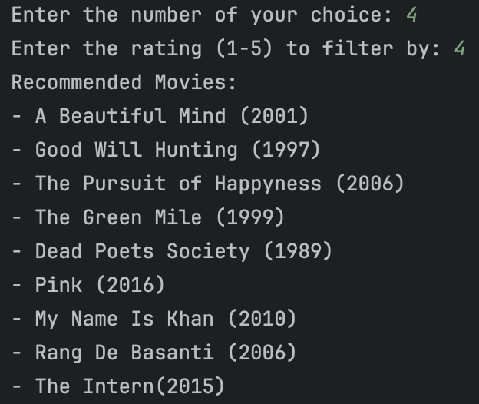

Output 2:

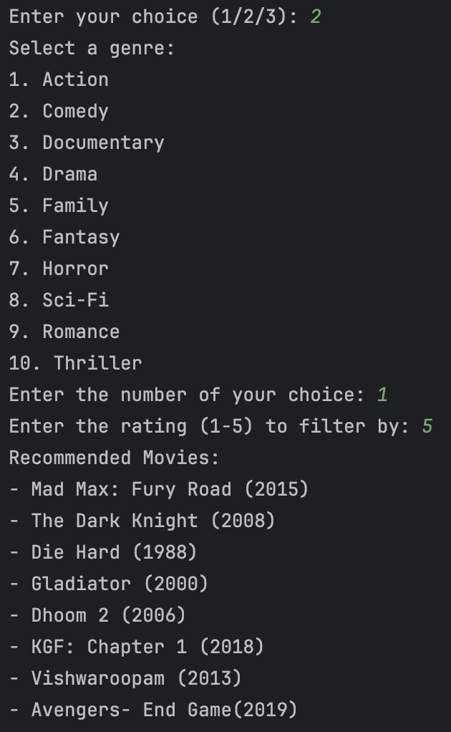

STEPS TO EXECUTE:

* To rate a movie, select option 1 i.e., Rate a Movie.
* Enter the movie title.
* Enter the movie genre.
* Enter your rating (1-5).
* The movie is now added to the database.
* To check whether the movie appears in the recommendations, select the option 2 i.e., Get Recommendation
* Select a genre.
* Enter the number of your genre choice.
* Enter the rating 1-5 to filter by.
* Recommended movies will appear on the output screen.

Output 3:

STEPS TO EXECUTE:

* To rate a movie, select option 1 i.e., Rate a Movie.
* Enter the movie title.
* Enter the movie genre.
* Enter your rating (1-5).
* The movie is now added to the database.
* To check whether the movie appears in the recommendations, select the option 2 i.e., Get Recommendation
* Select a genre.
* Enter the number of your genre choice.
* Enter the rating 1-5 to filter by.
* Recommended movies will appear on the output screen.

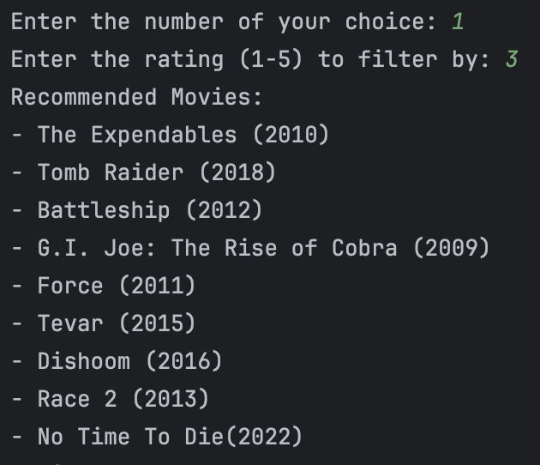

Output 4:

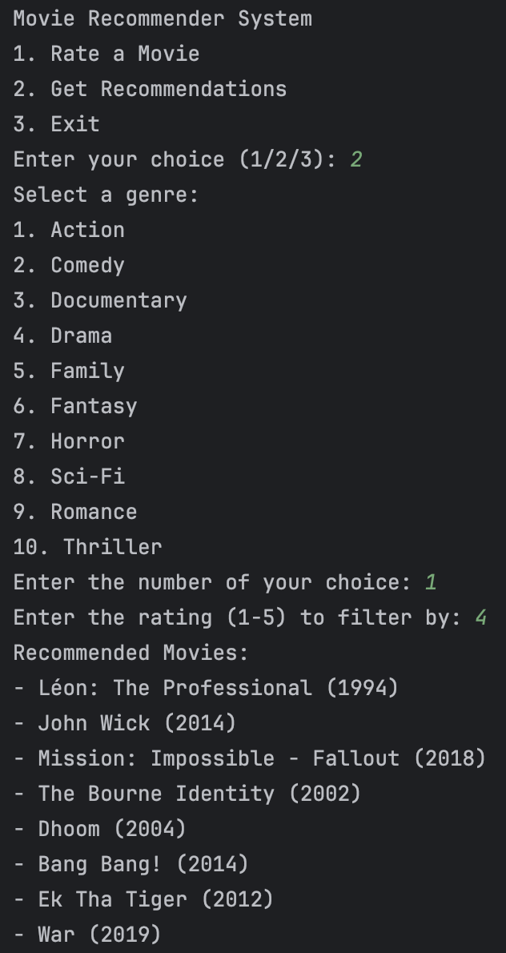

STEPS TO EXECUTE:

* To get movie recommendations, select option 2 i.e., Get recommendations.
* Select a genre.
* Enter the number of your genre choice.
* Enter your required rating 1-5 to filter by.
* Then recommended movies will appear on the output screen.

Output 5:

STEPS TO EXECUTE:

* To get movie recommendations, select option 2 i.e., Get recommendations.
* Select a genre.
* Enter the number of your genre choice.
* Enter your required rating 1-5 to filter by.
* Then recommended movies will appear on the output screen.

Output 6:

STEPS TO EXECUTE:

* To get movie recommendations, select option 2 i.e., Get recommendations.
* Select a genre.
* Enter the number of your genre choice.
* Enter your required rating 1-5 to filter by.
* Then recommended movies will appear on the output screen.

Output 7:

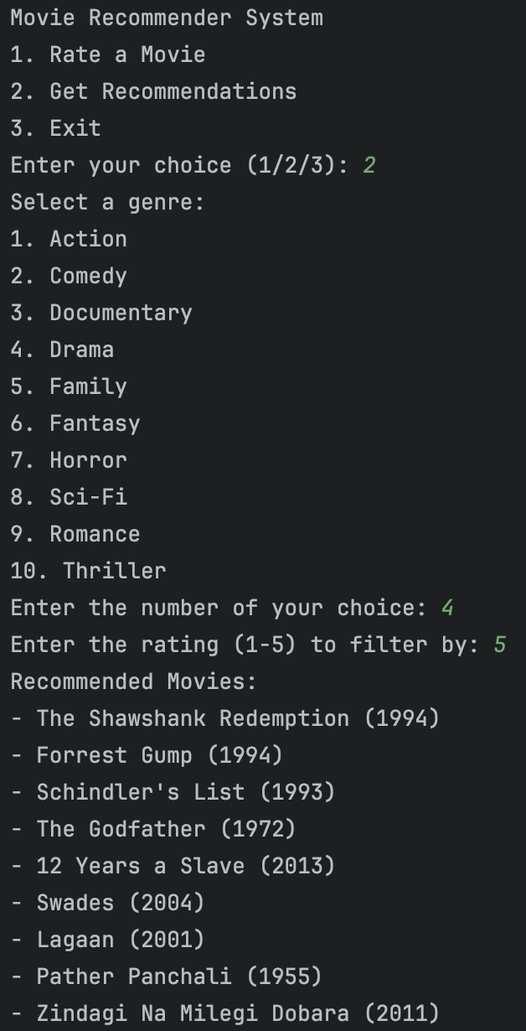

STEPS TO EXECUTE:

* To get movie recommendations, select option 2 i.e., Get recommendations.
* Select a genre.
* Enter the number of your genre choice.
* Enter your required rating 1-5 to filter by.
* Then recommended movies will appear on the output screen.

Output 8:

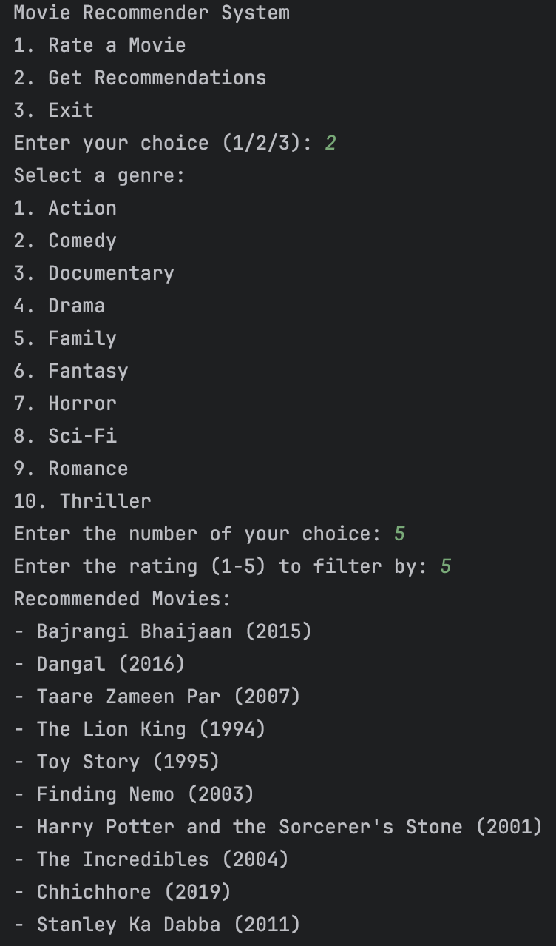

STEPS TO EXECUTE:

* To get movie recommendations, select option 2 i.e., Get recommendations.
* Select a genre.
* Enter the number of your genre choice.
* Enter your required rating 1-5 to filter by.
* Then recommended movies will appear on the output screen.

Output 9:

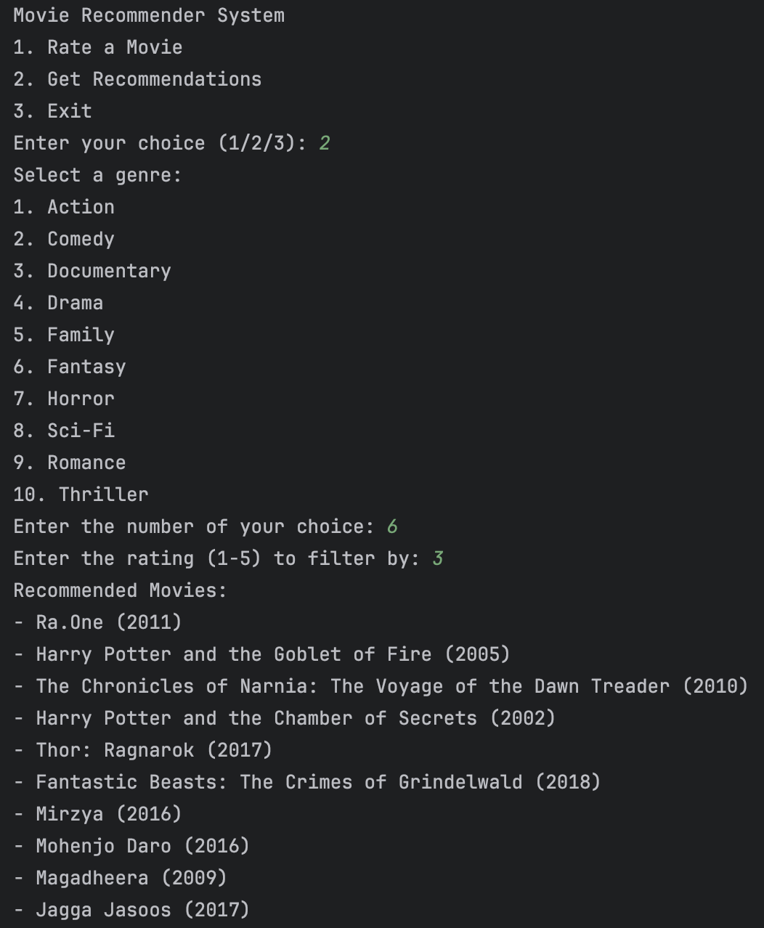

STEPS TO EXECUTE:

* To get movie recommendations, select option 2 i.e., Get recommendations.
* Select a genre.
* Enter the number of your genre choice.
* Enter your required rating 1-5 to filter by.
* Then recommended movies will appear on the output screen.

Output 10:

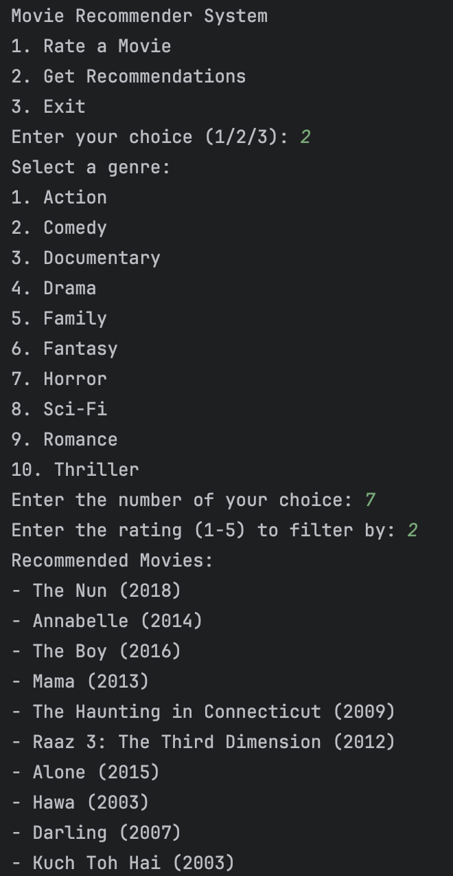

STEPS TO EXECUTE:

* To get movie recommendations, select option 2 i.e., Get recommendations.
* Select a genre.
* Enter the number of your genre choice.
* Enter your required rating 1-5 to filter by.
* Then recommended movies will appear on the output screen.

Output 11:

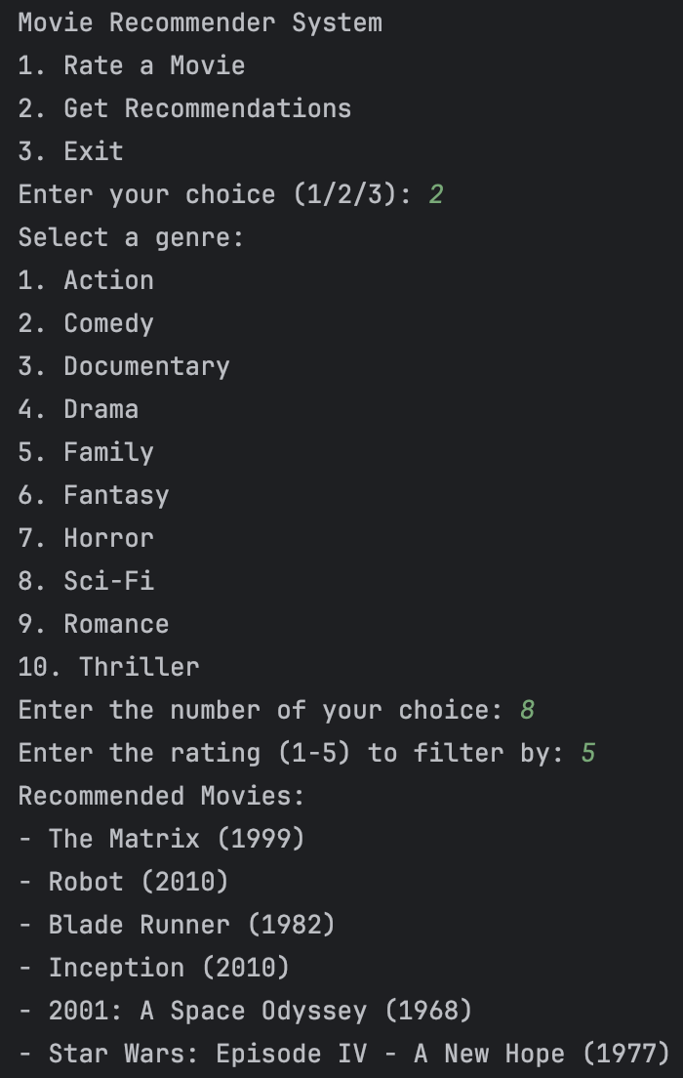

STEPS TO EXECUTE:

* To get movie recommendations, select option 2 i.e., Get recommendations.
* Select a genre.
* Enter the number of your genre choice.
* Enter your required rating 1-5 to filter by.
* Then recommended movies will appear on the output screen.

Output 12:

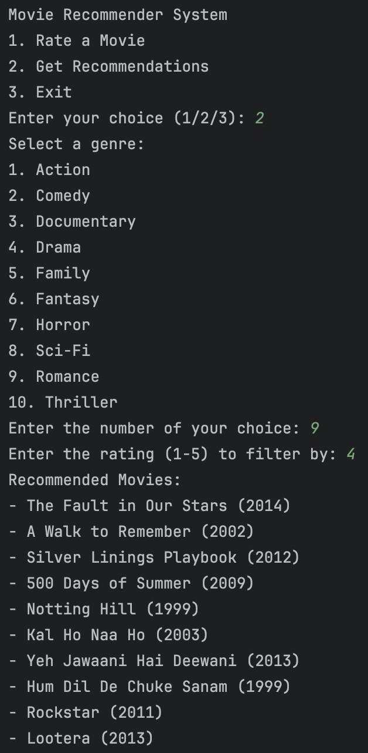

STEPS TO EXECUTE:

* To get movie recommendations, select option 2 i.e., Get recommendations.
* Select a genre.
* Enter the number of your genre choice.
* Enter your required rating 1-5 to filter by.
* Then recommended movies will appear on the output screen.

Output 13:

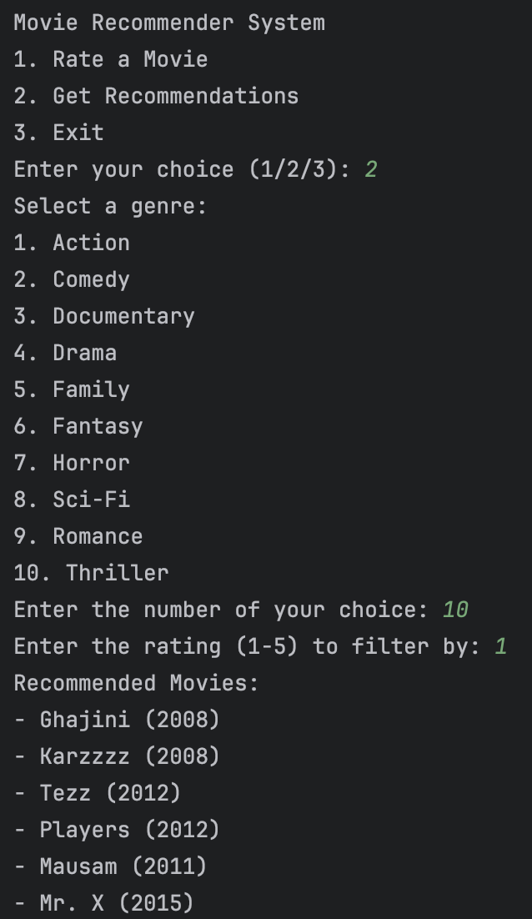

STEPS TO EXECUTE:

* To get movie recommendations, select option 2 i.e., Get recommendations.
* Select a genre.
* Enter the number of your genre choice.
* Enter your required rating 1-5 to filter by.
* Then recommended movies will appear on the output screen.

Output 14:

STEPS TO EXECUTE:

* To exit the output screen, select option 3 i.e., Exit.
* This will exit the movie recommender system.

**CONCLUSION**

In conclusion, the Python code provided implements a basic movie recommender system. It allows users to rate movies, select genres, and receive recommendations based on their preferences. The system relies on a predefined dictionary of movies, each categorized by genre and initial ratings. While functional, the system could be enhanced by incorporating more advanced recommendation algorithms, expanding the movie database, and improving the user interface for a more seamless experience. Overall, it serves as a good starting point for further development and customization in the realm of recommendation systems.